Task Report

Task Description
Data Collection Using SQL
- Discover the machines in your organization and their operating systems
- List only the machines that utilize the “OS 2” operating system.
- Obtain the office numbers of all the employees in the Finance and Sales departments.
- Using the up arrow for efficiency
- Filtering outputs using particular buildings
- Learning the LIKE and % indicators

Task
Find each machine in your organization and the operating systems each machine uses.

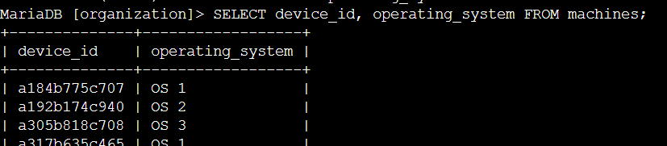
Command Semantics
    - SELECT device_id, operating_system FROM machines; The SELECT command tells the computer which columns to output, while the FROM command tells the machine which table to pull those columns from.

Next Task
List only the machines that utilize the “OS 2” operating system.

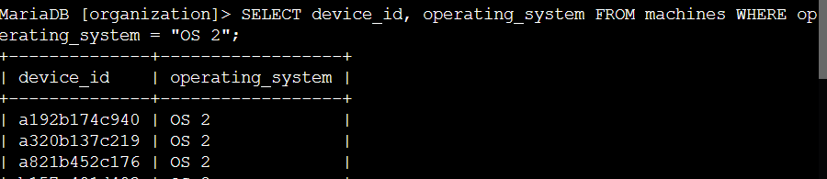

Command Semantics
    - SELECT device_id, operating_system FROM machines WHERE operating_system = “OS 2”; This input will return the columns “device_id”, and “operating_system” FROM the “machines” table, filtering out all results besides those where the “OS 2” operating system is listed using the WHERE input.
    - SELECT column(s)* FROM table WHERE column = 'column selector';

Various WHERE filters

Pattern | Results
a% | apple123, art, a
a_ | as, an, a7
a__ | ant, add, a1c
%a | pizza, Z6ra, a
_a | ma, 1a, Ha
%a% | Again, back, a
_a_ | Car, ban, ea7

Next Task
Obtain the office numbers of all the employees in the Finance and Sales departments. This information will be used to improve the company's security culture by posting a notice about how honorable it is to handle financial information in a confidential way.

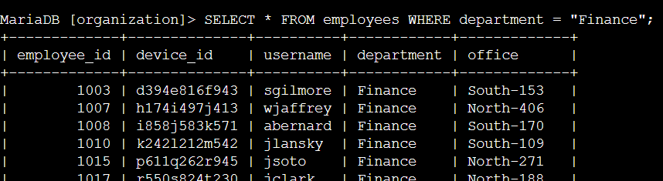

Command Semantics
    - SELECT * FROM employees WHERE department = “Finance”; This input tells the machine to query all columns (*), FROM the “employees” table WHERE the employee's department is listed as “Finance” description

Next Task
This task is the same as the previous step, but instead of outputting the employees in the finance department, discover the employees that are in the “Sales” department.

We can simply press the up arrow to return the previous query, then change “Finance” to “Sales

Command Semantics
    - SELECT * FROM employees WHERE department = “Sales”; This input tells the machine to query all columns (*), FROM the “employees” table WHERE the employees department is “Sales”. The “;” ends the input, acting like a period.

Next Task
Because there is an IT issue in the south building, we will discover information concerning the south building.

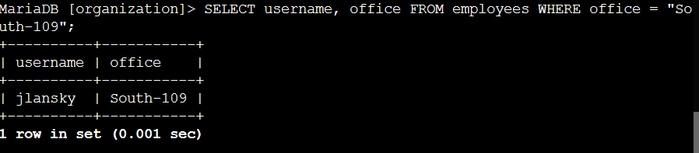

Command Semantics
    - SELECT office FROM employees WHERE office = “South-109”; The “office” column FROM the “employees” table will be queried WHERE only the employees whose office is in building “South-109” will be the output.

Next Task
All the machines in the south building are experiencing IT issues, so we will discover all of the employee's and their machines in the South building

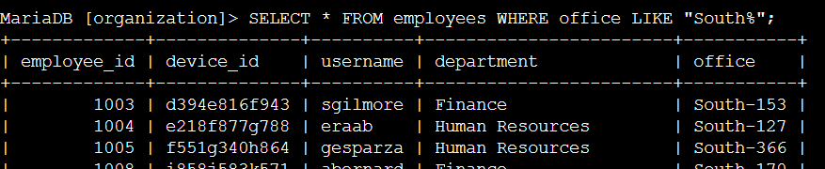

Command Semantics
    - SELECT * FROM employees WHERE office LIKE “South%”; This query will return all the columns in the “employees” table WHERE the information listed in the “office” column is “South%” - The “South%” input returns all inputs with any string following the “South” input. This would also work with the % indicator coming prior to the “South” input if, for instance, buildings were named as follows - “1_South”

Summary
We improved our organizations security posture by discovering all the employees in the finance department so a team member could deliver them a memo hotter than hot wings concerning confidentiality. We discovered all the machines in the south building which were having IT issues, we learned how to use the WHERE and = commands as well as the LIKE and % selectors. We also learned the handy up arrow trick to recall previous queries.

